# CS 255 System Design Document Template

This template lays out all the different sections that you need to complete for Project Two. Each section has guidance to prompt your thinking. You will need to continually reference the interview transcript as you work to make sure that you are addressing your client’s needs. There is no required length for the final document. Instead the goal is to complete each section based on what your client’s needs are. Remove this note when you are finished, and replace all bracketed text with the relevant information.

## UML Diagrams

### UML Use Case Diagram

### UML Activity Diagrams

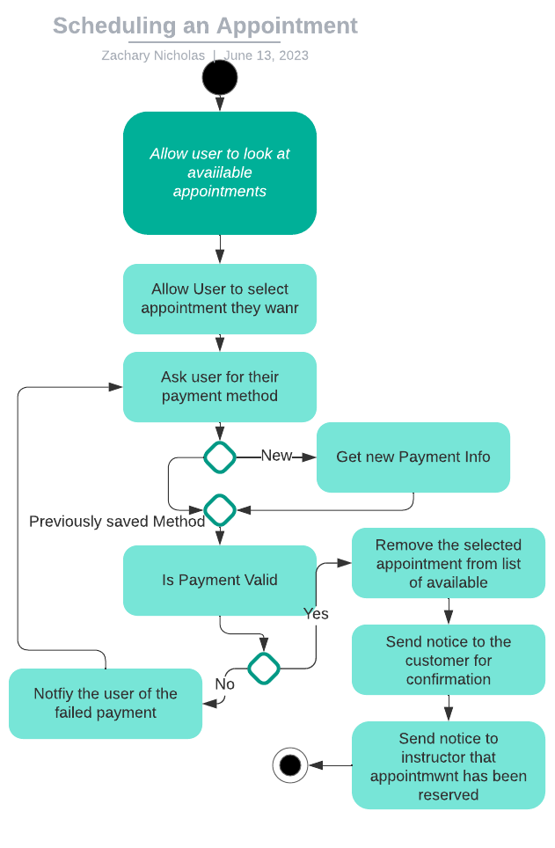

### UML Sequence Diagram

### UML Class Diagram

## Technical Requirements

Off what I designed I believe we should have some sort of host machine that will run our database as well as our web interface that all users will interact with. Some sort of payment processing service either one built by us or more likely one that has already been developed and we will use. And finally a computer for each of the designated staff such as one for our IT admin, one for our secretary, one for our instructors (either share amongst themselves or one for each if they can use their own), and finally one for the owner of the company to manage the rest of the services we provide.